Teleport Games UK Limited Proudly Presents:
THE DEVIL’S DICE!
An Ingenious game for all the family, and dedicated board players of all ages. The Game is based around strategy, AND TOTALLY relies on the LUCK of the DEVIL’S DICE.
Move around the board via the devil’s dice and knock off your opponent’s pieces to win the game.
The Game comes in 2 formats:
2-4 player version.
2-8 player version.
The game consists of each player having 4 counters which will represent Lives in the game. Players can choose to play 1, 2, 3, or all their counters at any time in the game. But only one counter can move in that turn.
Great Family fun in which a complete novice can become a world+++ Champion.
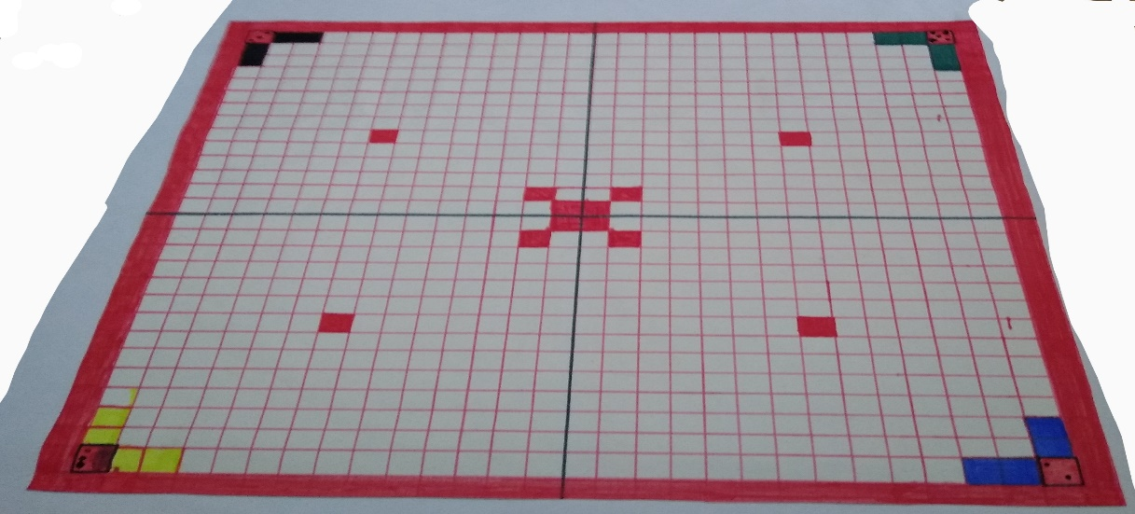

www.teleportgames.co.uk info@teleportgames.co.uk

